**Errors encountered:**

**STUDENT**

**DASHBOARD**

-**di naguupdate yung notification**. Nag upload classwork si adviser.

-yung nasa babang part pagnagunsubmit **may unsubmit button pa din**. dapat add or change na lang.

-**missing task** is meron pa sa unfinished classwork pero lagpas na sa deadline. (dapat nakalipat na siya sa missing task na tab.

-yung sa **classwork** pm yung selected na start date ni adviser pero ang nakadisplay is **AM**. Ang classwork ay ginawa noong 1:48 PM.

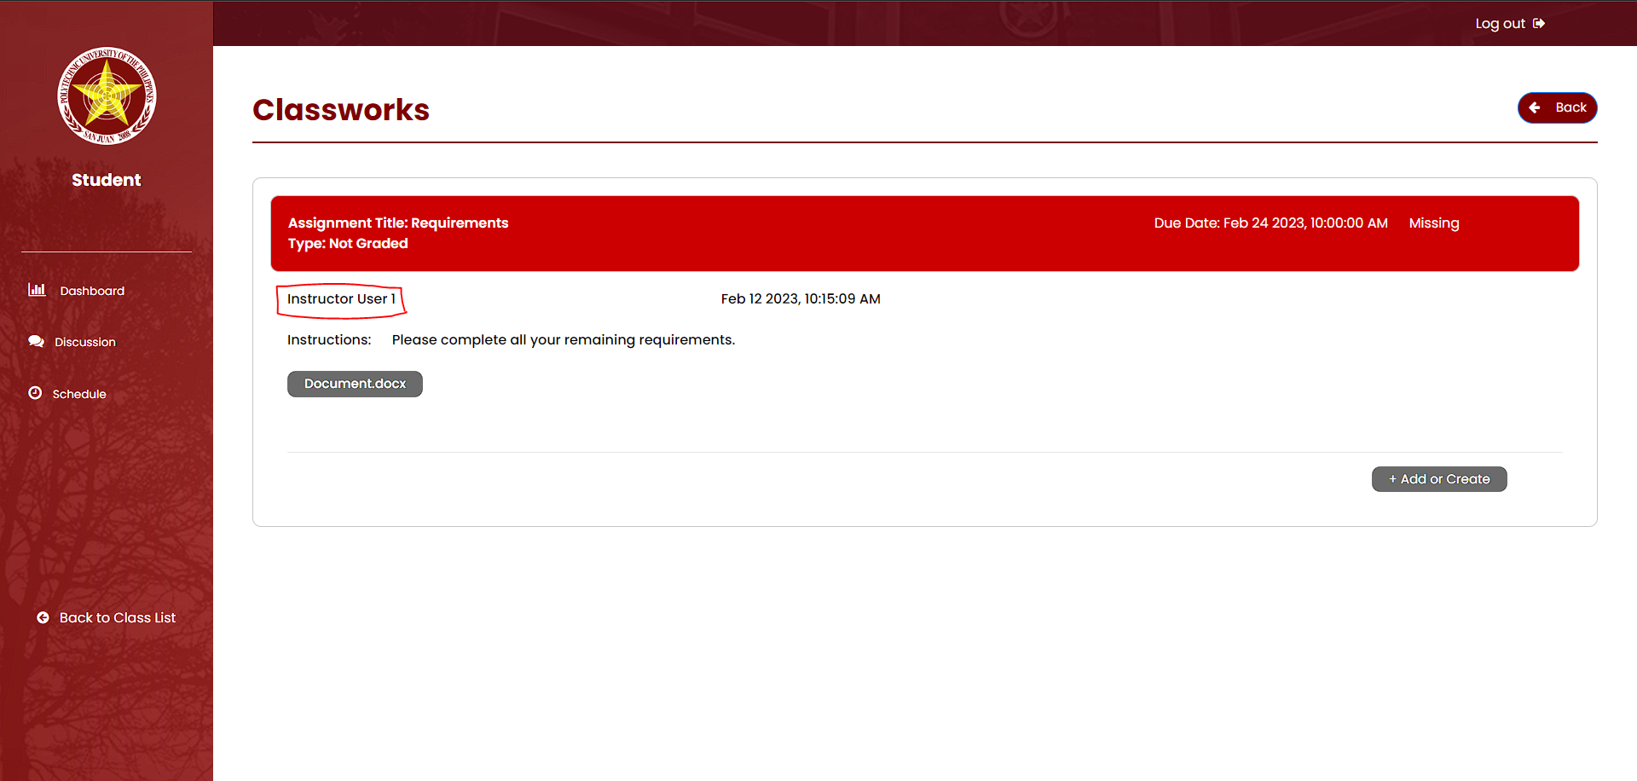

-**(unfinished classwork saka Missing Classwork)** name ni student yung nakalagay instead na instructor dapat.

=====================================================================================

DISCUSSION STUDENT

-walang sweet alert pagnag popost

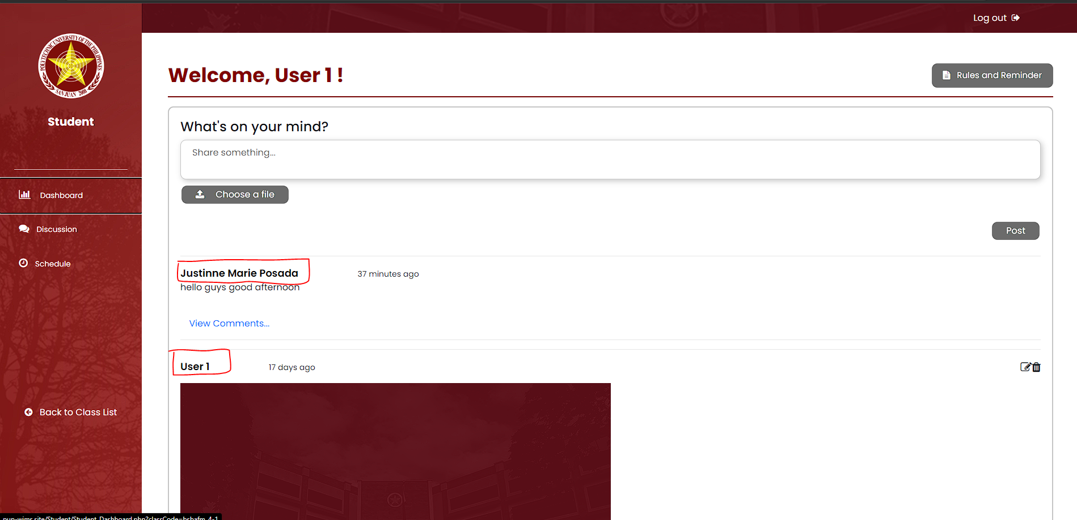

-users in discussion **should not be clickable**

=====================================================================================

Classwork

-**yung box nung file name maliit**, lumalagpas yung description pag mahaba

**SCHEDULE**

-merong **you do not have any meeting** pero may meeting siya.

**Suggestions:**

-Ilagay pangalan ng adviser ni student sa dashboard para makita and maconfirm and makilala niya.

**====================================================================================**

**ADVISER**

**ADVISER CREATE CLASS** - School year yung place holder dapat is ("e.g., 2012-2013")  
  
Design ng Create Class wala sa gitna. Tas sa baba instead na “to create eme eme”, ilagay mo na lang “fill out the form below” na lang since create class naman na yung pinuntahan nila

Dapat bawal mag lagay ng letter text sa section and school year or kahit sa section na lang bawal.

**ADVISER WORK** – dapat bawal ka mag submit ng walang file na nakaattached pag dating kay adviser.

**ADVISER STUDENTS TAB** – nag rerequest cannot handle sya, pag nag uupdate ng status and insurance.

**ADVISER PARTNER COMPANY LIST –** dapat di putol yung printing format, tas kung pwede na A4 size tas landscape.

* Graphical user interface, text, application, email

  Description automatically generatedDapat sana may indictor na di ka makakapag filter kung di ka nag fills up ng any of the needed information para makapag filter.

**Suggestion**: kung pwede nakalagay pangalan ng Adviser sa either dashboard or discussion para alam nila kung sino yung adviser nila since walang nakalagay yung sino yung adviser nila.

**ADVISER WORK** – PAG NAG SUBMIT NG MAY FILE ATTACHED, AFTER SUBMISSION NAWAWALA YUNG LAMAN NG NASA ADVISER WORK.

**====================================================================================**

**COORDINATOR**

Announcement

-dapat name ni adviser yung nakalagay sa may submiutted by, kasi baka di makilala ni coordinator

-diretso sa nagsubmit Nawala yung mga ginawang classwork ni coordinator, nakastuck sa image a sinubmit, di nacclick yung close

-nagloko na di na natatanggal